Contents

Example: AckermanExample2DKIN.xlsx 2

Example: Example3DCrankSlider3DDYN.xlsx 4

Example: ExampleCrankSlider2DKIN.xlsx 5

Example: ExamplePendulum2DDYN.xlsx 6

Example: ExampleRarm3DKIN.xlsx 7

Example: ExampleSpringDamper2DDYN.xlsx 8

# Example: AckermanExample2DKIN.xlsx

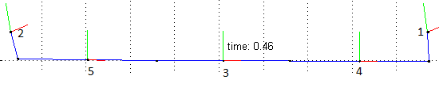

This simulation is of an example steering system incorporating pro Ackerman settings (dynamic toe). Where when turning the inside wheel of a vehicle with turn more than the outside wheel, due to the different radius’s each wheel tracks. This system incorporates a steering rack (body 3), two tie rods (body 5,4) and the wheel themselves (body(1,2)). The rack (body 3) is moved along the x direction with a driving constraints. The inner wheel (body 2) moves more than the outer (body 1) due to left hand turn. Body 1 and 2 is connected to ground via revolute constraint.

The static angle between the tie rod and the steering arm in the wheel determines the Ackerman setting (shown below). Where if the angle was 90 degrees this is known as parallel steer, above 90 degrees pro Ackerman (inner turns more then outer) and below 90 degrees anti Ackerman (outer turns more than inner).

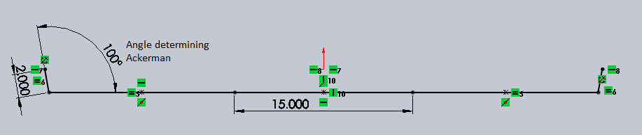

System Definition:

Body Dof: 15 – 6 rev * 2 – 3 driver = SYSTEM DOF: 0

Body initial positions

Body 1 X: 23.5 Y: 1.96962 Phiz: 0

Body 2 X: -23.5 Y: 1.96962 Phiz: 0

Body 3 X: 0 Y: 0 Phiz: 0

Body 4 X: 15.32635 Y: 0 Phiz: 0

Body 5 X: -15.32635 Y: 0 Phiz: 0

Constraint information

Rev1 bodyi: 0 bodyj: 1 Pix: 23.5 Piy: 1.96962 Pjx: 0 Pjy: 0

Rev2 bodyi: 0 bodyj: 2 Pix: -23.5 Piy: 1.96962 Pjx: 0 Pjy: 0

Rev3 bodyi: 2 bodyj: 5 Pix: .3573 Piy: -1.96962 Pjx: -7.82635 Pjy: 0

Rev4 bodyi: 1 bodyj: 4 Pix: -.3573 Piy: -1.96962 Pjx: 7.82635 Pjy: 0

Rev5 bodyi: 3 bodyj: 4 Pix: 7.5 Piy: 0 Pjx: -7.82635 Pjy: 0

Rev6 bodyi: 3 bodyj: 5 Pix: -7.5 Piy: 0 Pjx: 7.82635 Pjy: 0

Driver Information

Body 3 Coordinate: Y f(t): 0 d/dt(f(t)): 0 d^2/dt^2(f(t)): 0

Body 3 Coordinate: X f(t): t d/dt(f(t)): 1 d^2/dt^2(f(t)): 0

Body 3 Coordinate: PHI f(t): 0 d/dt(f(t)): 0 d^2/dt^2(f(t)): 0

Results: Outputted excel data, that has been processed to show useful information. Shows the inner and outer wheel degrees per rack travel. And then the angle difference per rack travel.

# Example: Example3DCrankSlider3DDYN.xlsx

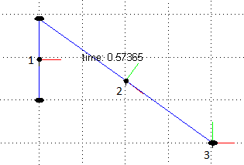

This simulation is a 3d Crank slider, where the crank (body 1) rotates about the x axis and comes out of the xy plane. A revolute is used between body 1 and 0 and also 2 and 3. The cylindrical joint is used on body 3, and rotates due to the revolute joint used. A spherical joint is used between body 1 and 2 to allow the last DOF.

Body Dof: 18 – 2 rev * 5 – 1 sph * 3 – 1 cyl * 4 = SYSTEM DOF: 1

Initial Positions:

Body 1: X: 0 Y: 1 Z: 0 PHIX: 0 PHIY: 0 PHIZ: 0 Xd: 0 Yd: 0 Zd: 0 wx: 0 wy: 0 wz: 0

Mass: 1 Ixx: .1 Iyy: .1 Izz: .1 Fx: 0 Fy: -32 Fz:0 Tx:2 Ty:0 Tz: 0

Body 2: X: 2 Y: .5 Z: 0 PHIX: 0 PHIY: 0 PHIZ: 323.13 Xd: 0 Yd: 0 Zd: 0 wx: 0 wy: 0 wz: 0

Mass: 1 Ixx: .1 Iyy: .1 Izz: .1 Fx: 0 Fy: -32 Fz:0 Tx:0 Ty:0 Tz: 0

Body 3: X: 4 Y: -1 Z: 0 PHIX: 0 PHIY: 0 PHIZ: 0 Xd: 0 Yd: 0 Zd: 0 wx: 0 wy: 0 wz: 0

Mass: 5 Ixx: .1 Iyy: .1 Izz: .1 Fx: 0 Fy: -160 Fz:0 Tx:0 Ty:0 Tz: 0

Constraints:

Rev1: i: 0 j: 1 Pix: 0 Piy: 0 Piz: 0 Qix: -1 Qiy: 0 Qiz: 0 Pjx: 0 Pjy: -1 Pjz: 0 Qjx: 1 Qjy: -1 Qjz: 0

Sph1: i: 1 j: 2 Pix: 0 Piy: 1 Piz: 0 Qix: 0 Qiy: 0 Qiz: 0 Pjx: -2.5 Pjy: 0 Pjz: 0 Qjx: 0 Qjy: 0 Qjz: 0

Rev2: i: 2 j: 3 Pix: 2.5 Piy: 0 Piz: 0 Qix: 2.5 Qiy: 0 Qiz: -1 Pjx: 0 Pjy: 0 Pjz: 0 Qjx: 0 Qjy: 0 Qjz: 1

Trans: i: 0 j: 3 Pix: 0 Piy: -1 Piz: 0 Qix: -1 Qiy: -1 Qiz: 0 Pjx: 0 Pjy: 0 Pjz: 0 Qjx: 1 Qjy: 0 Qjz: 0

# Example: ExampleCrankSlider2DKIN.xlsx

This system models a simple crank slider mechanism in a 2d kinematic simulation.

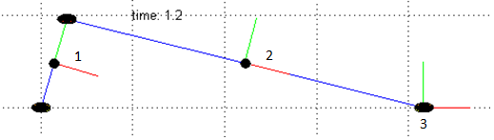

Body 1 is the crank, Body 2 is the link and body 3 is the slider along the X direction. A simple planar crank slider system.

The system is defined as below.

3 bodies * 3 coord = 9

3 revolute * 2 + 1 translation * 2 + 1 driver = 9

System DOF = 9-9 = 0

Body initial positions

Body 1 X: 0 Y: 0.5 Phiz: 90

Body 2 X: 1.93649 Y: 0.5 Phiz: 345.52

Body 3 X: 3.87298 Y: 0 Phiz: 0

Constraint information

Rev1 bodyi: 0 bodyj: 1 Pix: 0 Piy: 0 Pjx: 0 Pjy: -.5

Rev2 bodyi: 1 bodyj: 2 Pix: 0 Piy: 0.5 Pjx: -2 Pjy: 0

Rev3 bodyi: 2 bodyj: 3 Pix: 2 Piy: 0 Pjx: 0 Pjy: 0

Trans1 bodyi: 0 bodyj: 3 Pix: 0 Piy: 0 Qix: 1 Qiy: 0 Pjx:0 Pjy:0

Driver Information

Body 1 Coordinate: phi f(t): 5*t d/dt(f(t)): 5 d^2/dt^2(f(t)): 0

# Example: ExamplePendulum2DDYN.xlsx

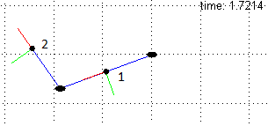

This simulation is of a simple double pendulum. Two bodies are used, body 1 is attached to ground, body 2is attached to the center of body 1. Revolute joints are used in the analysis. The pendulum is allowed to swing based off gravity.

Body Dof: 6 – 2 rev *2 = SYSTEM DOF: 2

Body initial positions

Body 1 X: 1 Y: 0 Phiz: 0 Xd: 0 Yd: 0 wz: 0 Mass: 5 Izz: .1 Fx: 0 Fy: -50 Tz: 0

Body 2 X: 3 Y: 0 Phiz: 0 Xd: 0 Yd: 0 wz: 0 Mass: 5 Izz: .1 Fx: 0 Fy: -50 Tz: 0

Constraint information

Rev1 bodyi: 0 bodyj: 1 Pix: 0 Piy: 0 Pjx: -1 Pjy: 0

Rev2 bodyi: 1 bodyj: 2 Pix: 1 Piy: 0 Pjx: -1 Pjy: 0

# Example: ExampleRarm3DKIN.xlsx

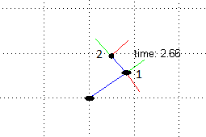

This example utilizes 3d Kinematic solver to solve a double pendulum, where each body has prescribed rotations. Body 1 is hinged about the ground 0,0. Body 2 is hinged about the center of body 1. Revolute constraints are used to avoid any out of plane movement.

Body Dof: 12 – 2 rev * 5 – 2 drv = SYSTEM DOF: 0

Initial Positions:

Body 1: X: 0 Y: 1 Z: 0 PHIX: 0 PHIY: 0 PHIZ: 0

Body 2: X: 0 Y: 1.5 Z: 0 PHIX: 0 PHIY: 0 PHIZ: 0

Constraints:

Rev1: i: 0 j: 1 Pix: 0 Piy: 0 Piz: 0 Qix: 0 Qiy: 0 Qiz: -1 Pjx: 0 Pjy: -1 Pjz: 0 Qjx: 0 Qjy: -1 Qjz: 1

Rev2: i: 1 j: 2 Pix: 0 Piy: 0 Piz: 0 Qix: 0 Qiy: 0 Qiz: -1 Pjx: 0 Pjy: -0.5 Pjz: 0 Qjx: 0 Qjy: -0.5 Qjz: 1

Driving Constraints:

Body 1 Coordinate: phiz f(t): 2*t d/dt(f(t)): 2 d^2/dt^2(f(t)): 0

Body 2 Coordinate: phiz f(t): 5*t d/dt(f(t)): 5 d^2/dt^2(f(t)): 0

Result: body 2: X position vs body 2: Y position

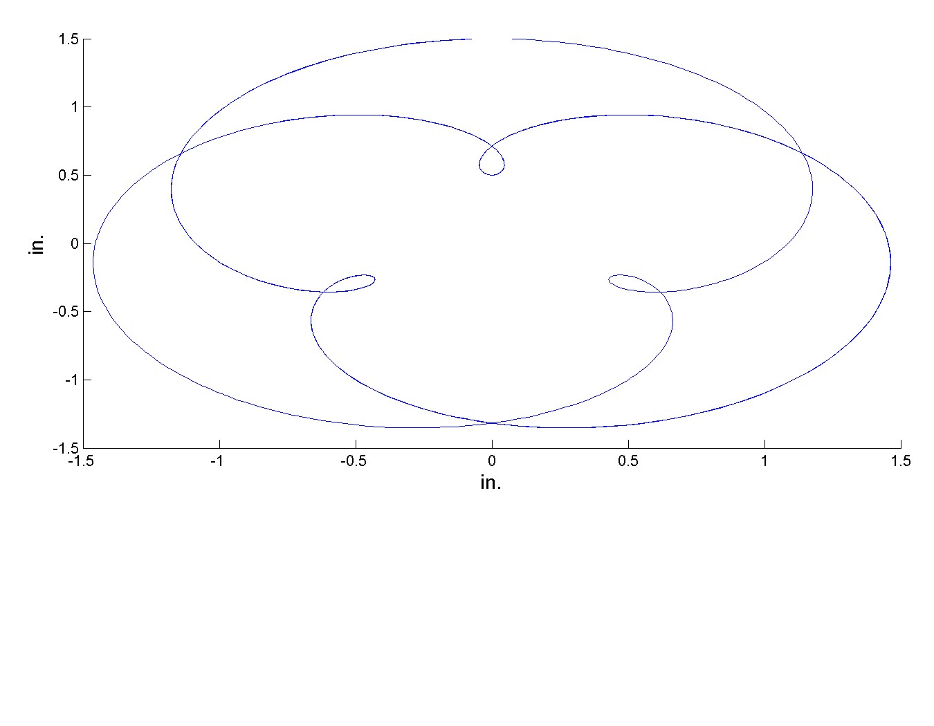

# Example: ExampleSpringDamper2DDYN.xlsx

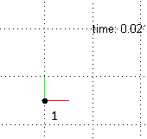

This is a simple spring damper system that demonstrates the dynamic capabilities that can be incorporated with the models. A spring is attached to body 1 and the ground a 0,0. A spring constant of 50 lb/in and a damping factor of 3 lb/in^2 is used. The spring is put in a compressed length of .5” with the initial length being 1”. Simulation is a 2D dynamic sim. DOF = 3

Initial Position:

Body 1: X: 0 Y: -.5 Phiz: 0 Xd: 0 Yd: 0 Wz:0 Mass: 5 Izz: .1 Fx: 0 Fy: -165 Tz: 0

No Constraints – Unconstrained System

Spring Damper Information

Bodyi: 0 Bodyj: 0 Pix:0 Piy: 0 Pjx: 0 Pjy:0 Iniitial_L: 1 K: 50 C: 3 F:0

Result: body 1: Y position

